ish¿u ysñlï weúßKs $ All Rights Reserved

St. Peter's College

St. Peter's College

St. Peter's College

புனித பேதுரு கல்லூரி

புனித பேதுரு கல்லூரி

புனித பேதுரு கல்லூரி

புனித பேதுரு கல்லூரி

புனித பேதுரு கல்லூரி

புனித பேதுரு கல்லூரி

புனித பேதுரு கல்லூரி

புனித பேதுரு கல்லூரி

Ydka; mS;r úÿy,

Ydka; mS;r úÿy,

Ydka; mS;r úÿy,

Ydka; mS;r úÿy,

Ydka; mS;r úÿy,

Ydka; mS;r úÿy,

Ydka; mS;r úÿy,

Ydka; mS;r úÿy,

Ydka; mS;r úÿy,

Ydka; mS;r úÿy,

St. Peter's College

St. Peter's College

St. Peter's College

St. Peter's College

St. Peter's College

St. Peter's College

St. Peter's College

St. Peter's College

St. Peter's College

St. Peter's College

புனித பேதுரு கல்லூரி

புனித பேதுரு கல்லூரி

புனித பேதுரு கல்லூரி

புனித பேதுரு கல்லூரி

புனித பேதுரு கல்லூரி

புனித பேதுரு கல்லூரி

புனித பேதுரு கல்லூரி

புனித பேதுரு கல்லூரி

Ydka; mS;r úÿy,

Ydka; mS;r úÿy,

Ydka; mS;r úÿy,

Ydka; mS;r úÿy,

Ydka; mS;r úÿy,

Ydka; mS;r úÿy,

Ydka; mS;r úÿy,

Ydka; mS;r úÿy,

Ydka; mS;r úÿy,

Ydka; mS;r úÿy,

St. Peter's College

St. Peter's College

St. Peter's College

St. Peter's College

St. Peter's College

St. Peter's College

St. Peter's College

61

E

**N+f.da,h**

**Geography**

**meh**

**Hour**

**02**

**07 fY%aKsh – fojk jdr we.hsu - 2023**

***Grade 07 – Second Term Examination - 2023***

Ydka; mS;r úÿy, - fld<U 04

புனித பேதுரு கல்லூரி, கொழும்பு 4

***St. Peter's College - Colombo 04***

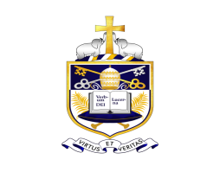

Name:……………………………………………………….. Class:………. No:……….

**Part A**

**Answer all the questions.**

² **Select the most suitable word and write in the given space for questions 01 to 05.**

01. South Latitude is called the **(Antarctic / Arctic / North)** __________________ circle.

02. Showing the location of a country with reference to longitudes and latitudes is the **(specific / relative / immediate)** __________________ location.

03. The lands located between 30m - 300m sea level are called __________________ **(Intermediate / Coastal / Central)** plains.

04. The periodical winds blow into the country from South west and North west are called __________________ **(Monsoons / Cyclones / Convectional rains)**.

05. The attractive coastal area like __________________ **(Pasi kuda / Delft / Nuwaraeliya)**.

**(2 $×$ 5 $=$ 10)**

² **Mark $√$ or $×$ for question 06 to 10.**

06. The equator is the horizontal line found on the middle of the globe ( )

07. Australia is a single country; though it is the smallest continent. ( )

08. Caspian sea is found in the continent of North America ( )

09. Months of October, November and December bring cyclones to Sri Lanka. ( )

10. Kayts close to Jaffna peninsula has a religious importance ( )

² **Write the most suitable answer in the given space for questions 11 to 15.**

11. The imaginary lines drawn from the North to South pole on the Globe are named as __________________.

12. The length from __________________ to Dondra head in Sri Lanka map is 432 km.

13. __________________ is the cluster of islands in the South Asian region.

14. The __________________ built by blocking the rivers flow through the small ridges are very prominent in the Dry Zone.

15. __________________ does not receive rainfall by the main types of rain in Sri Lanka.

² **Select the most appropriate answer and underline from questions 16 to 20.**

16. The biggest ocean in the world is,

i. Indian ocean ii. Pacific ocean

iii. Arctic ocean iv. Antarctic ocean

17. The mangroves are found abundantly around,

i. Valleys ii. Lagoons iii. Gaps iv. Rivers

18. The longitude is named as,

i. Greenwich prime meridian ii. The equator

iii. The tropics iv. The North pole

19. Free trade zone is found in,

i. Katunayake ii. Colombo

iii. Jaffna iv. Kaluthara

20. Convectional rains occur in Sri Lanka during the months of,

i. November / December ii. March, April and September, October

iii. December iv. January / February

**(2 $×$ 20 $=$ 40)**

**Part B**

² **Answer five questions including the first questions.**

² **First question is compulsory.**

**01. Study the world map and answer the questions.**

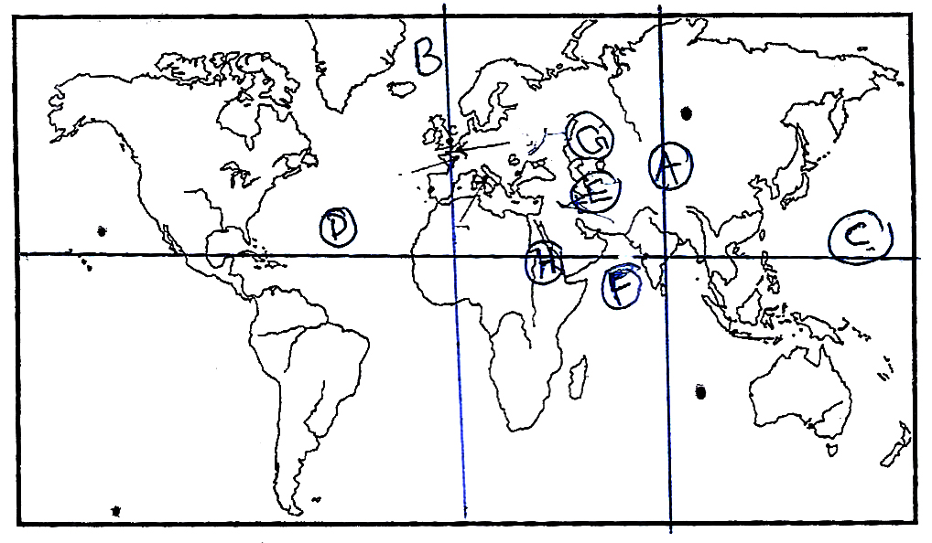

1. The value of the Eastern longitude shown by letter (A)

2. The name of the longitude shown by letter (B)

3. The name of the latitude shown by (C)

4. What is the ocean named as (D)

5. Name (E) and (G) that are inland seas.

6. Name (H) and (F) that are seas. **(Total 08 Marks)**

**(B). Study the Sri Lanka map and answer.**

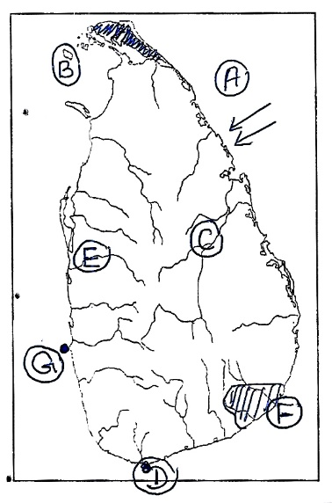

1. The type of rainfall shown by (A) **(01)**

2. Name the island shown by (B) **(01)**

3. The shaded area in the map is named as. **(01)**

4. Name the river shown by (C) **(01)**

5. What is the point named as (D)

6. Name the river (E) that is a boundary for a main landscape.

7. The national park in letter (F).

8. What is named as (G) that is the commercial city of Sri Lanka.

**(Total 16 Marks)**

**02. Fill in the blanks with the help of the factors contribute towards the social development of Sri Lanka.**

Ability to obtain a

nutritious meal

1. 1.

2. **(02)**

2. 1.

Development of

educational facilities

2.

3. **(03)**

3. Mention 03 factors affected to the higher level of literacy in Sri Lanka.

1.

2.

3. **(06)**

**(Total 11 Marks)**

**03. Fill in the puzzle.**

1. An island closer to Jaffna peninsula.

2. A beautiful coastal area.

3. A Hindu Temple is found in here

4. A physical landscape found in the coastal landscape.

5. An island found in the Indian Ocean.

6. A bird sanctuary.

7. An industry carried out based on the resources found in the coastal area.

8. A basic feature in maps.

9. It is compulsory to read maps with the help of this.

10. Hikkaduwa is famous for this.

11. A man made tangible heritage in the dry zone.

i. ii.

P

P

P

P

P

P

P

P

D

D

D

D

L

L

L

L

L

L

L

N

N

N

N

N

N

iii. iv.

M

M

M

M

M

M

M

M

v. vi.

C

C

C

C

C

C

C

C

C

C

C

S

S

S

S

C

C

C

C

vii. viii.

ix. x.

C

C

C

C

C

C

K

K

K

xi. **(11 Marks)**

S

S

S

S

S

S

S

S

**04. A landscape found in Sri Lanka is given in the map with rivers.**

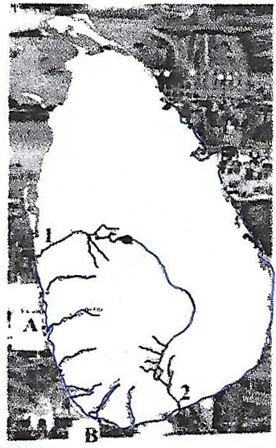

1. i. What are boundaries of this landscape?

ii. Name the landscape **(02)**

2. Name 03 types of agricultural lands found in this land scape. **(03)**

3. i. Write 03 towns where free trade zones are located.

µµµ' **(03)**

ii. Write 03 towns with urban industrial centers in the above landscape. **(03)**

**(Total 11 Marks)**

**05. Sri Lanka is one of the South Asian countries with a higher literacy.**

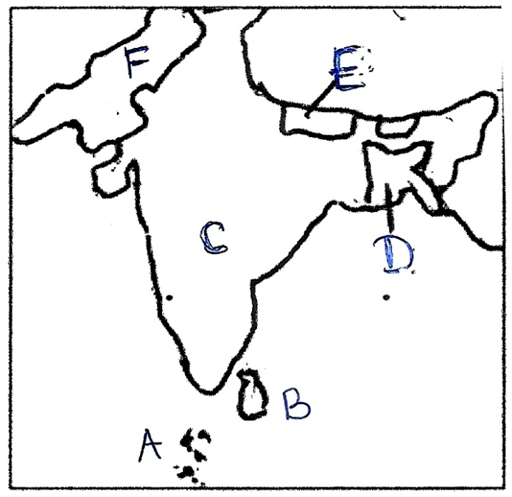

1. Name 02 South Asian countries with higher social

development. **(02)**

2. Write 03 types of units of measurements used on

social development of South Asian countries.

**(03)**

3. Name the countries shown by letters.

A -

B -

C -

D -

E -

F - **(06)**

**(Total 11 Marks)**

**06. More of the area in Sri Lanka belongs to the dry zone.**

1. Name 02 districts in the dry zone. **(02)**

2. Write 03 factors on which the landscape of dry zone is set. **(03)**

3.

The dry zone

Human landscape

1.

2.

3.

Physical landscape

4.

5.

6.

**(06)**

**(Total 11 Marks)**

**07.** 1. Name 02 main relief zones in Sri Lanka; including where you live in. **(02)**

2. Write the specific location of Sri Laanka. **(03)**

3. All the __________________ states were granted the __________________ of a limit of __________________ miles from the __________________ by the __________________ of the __________________.

**(11 Marks)**